TAFJ UPGRADED:

* Download TAFJ Dev of the target version and run the patch file.

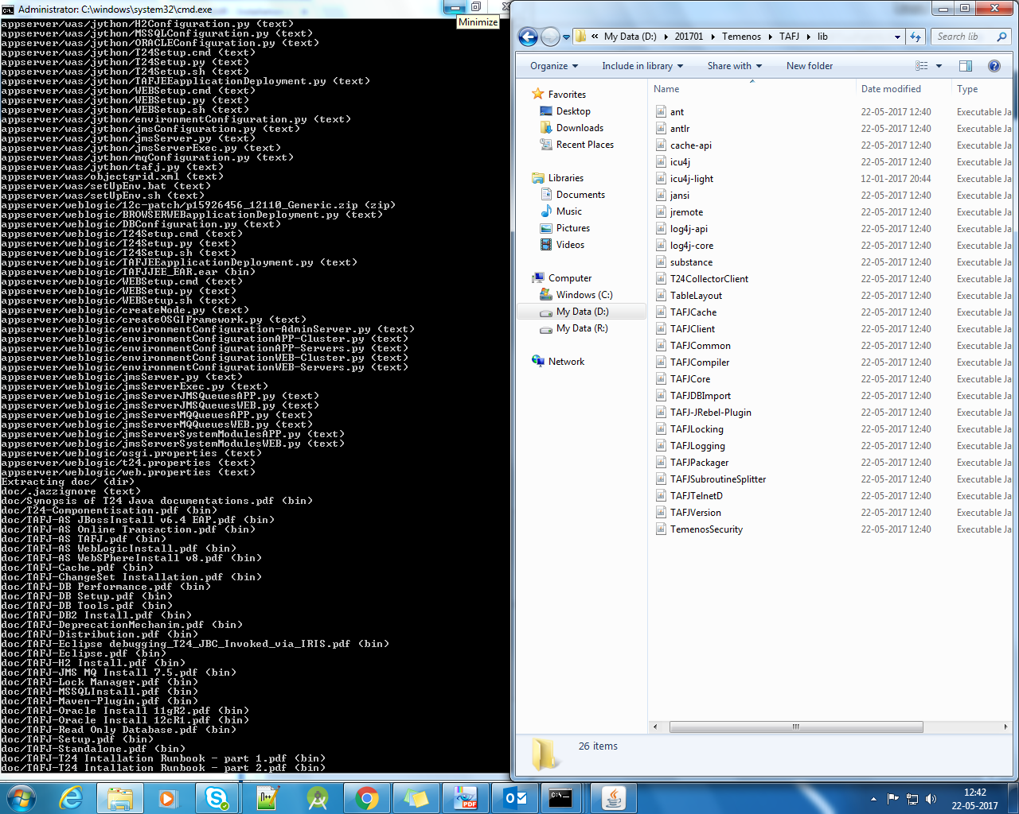

* STOP JBOSS
* EXECUTE THE COMMAND FROM TAFJ BIN
* NOTE: ADD TEMP>RELEASE TO TAFJ CURRENT DIRECTORY FOLDER ONLY

DBTools -u t24user -p Temenos_123 -log tmprelease1.log TEMP-RELEASE D:\201701\Temenos\t24home\default\temp.release D:\201701\Temenos\jboss\modules\com\temenos\t24\main -bp D:\201701\Temenos\t24home\default\temp.release\BP

WHERE

D:\201701\Temenos\t24home\default\temp.release-source downloaded

D:\201701\Temenos\jboss\modules\com\temenos\t24\main-precompiled folder

D:\201701\Temenos\t24home\default\temp.release\BP-basic folder in source

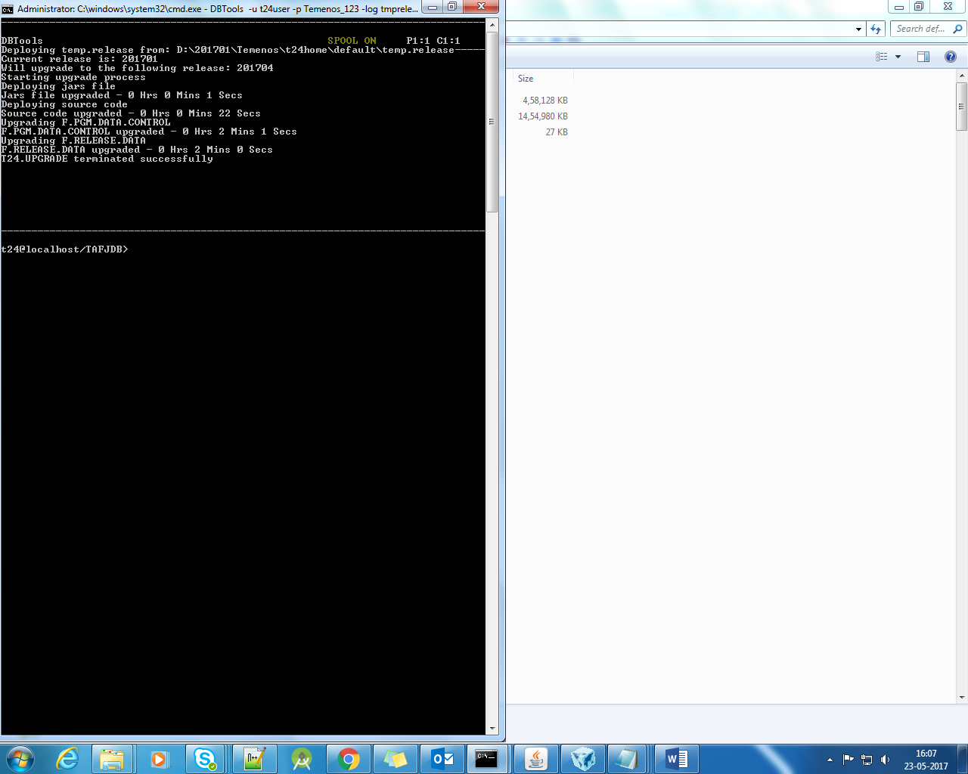

* Run the routine T24.PRE.RELEASE

Sysntax tRun T24.PRE.RELEASE

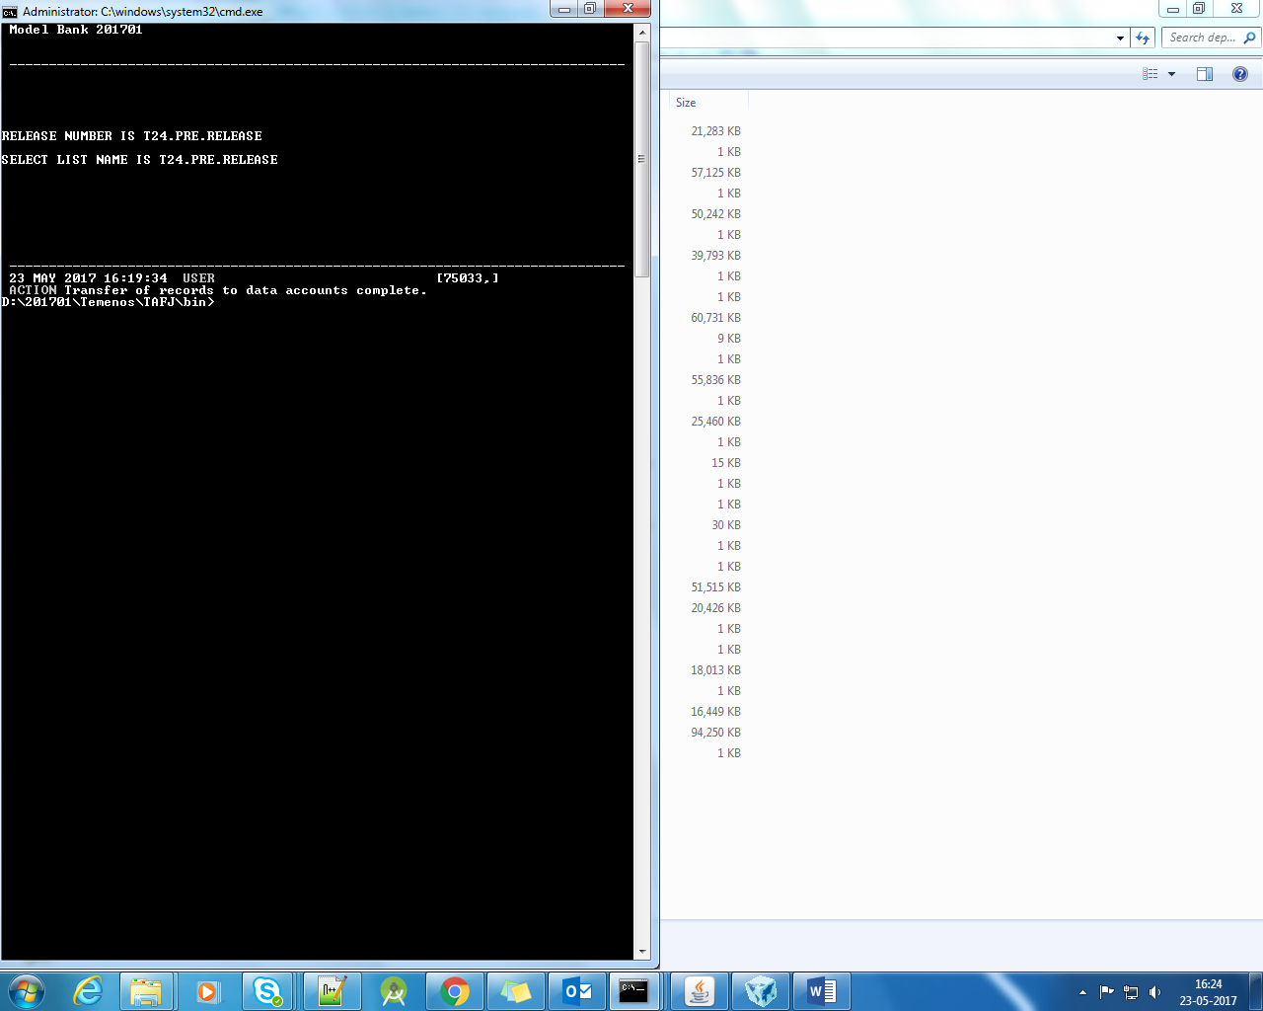

* Run the service T24.UPGRADE

Start the agent repetitively until the agent listed in TSM stops prompting.

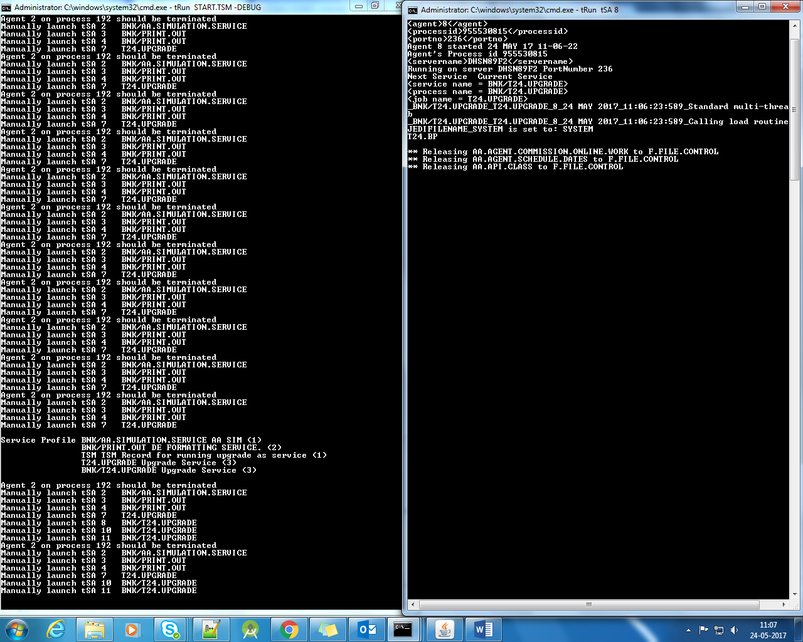

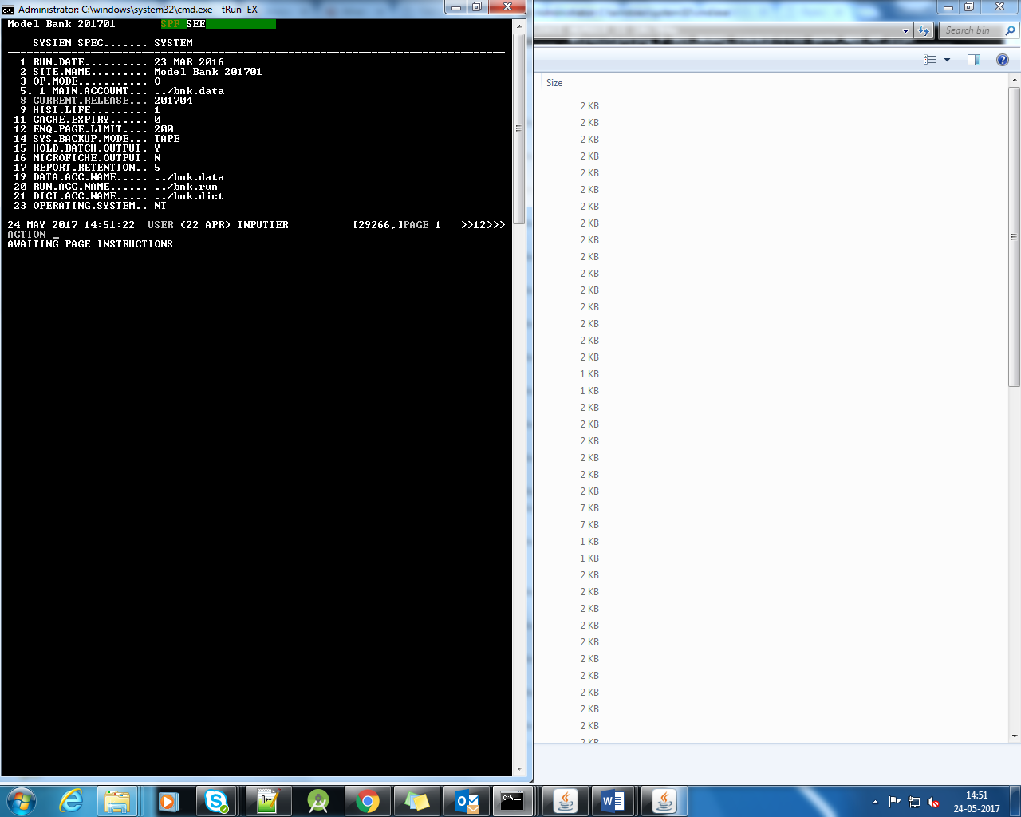

* Run the service RUN.CONVERSION

